«ContactName»
«ContactPostalAddress»
«ContactTaxDisplayName» «ContactTaxNumber»

«InvoiceDate»
Receipt Number: «InvoiceNumber»
Official Tax Receipt
Living Business Charity gratefully received a donation of $«TableStart:LineItem»«LineAmount» for the «Description» «TableEnd:LineItem» from «ContactName» on «InvoiceDate».

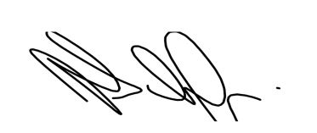
Helen Schafer
Director

Living Business Sample Charity incorporated
GST number 123-456-789
Charities Commission Number: ABC123

